**Preamble: If you want to use a machine outside of the laboratory.**

Blender 2.8 is installed in the laboratories (Windows 10 Image) so you should be able to do the assignment straightaway. If you want to get it running on another machine, you will need to download and install it. Blender supports Linux, Window and Mac-iOS.

<https://www.blender.org/download/>

Blender installs the python it needs so you should not have to do this. The version found on my machine was 3.6.1. but I have seen it run on a machine with 3.7



Optional: I needed to add the maths utility package for python for the first scripting tutorial so from the command line enter the following.

**pip install mathutils** or possibly **sudo pip install mathutils**

or if the path is not set

**py -m pip install mathutils**

If you don’t have Visual Studio on your machine, then you will need to install MS Build Tools so that mathutils can be compiled by pip.

<https://visualstudio.microsoft.com/thank-you-downloading-visual-studio/?sku=BuildTools&rel=16>

[https://docs.blender.org/api/current/mathutils.html - mathutils.Quaternion](https://docs.blender.org/api/current/mathutils.html#mathutils.Quaternion)

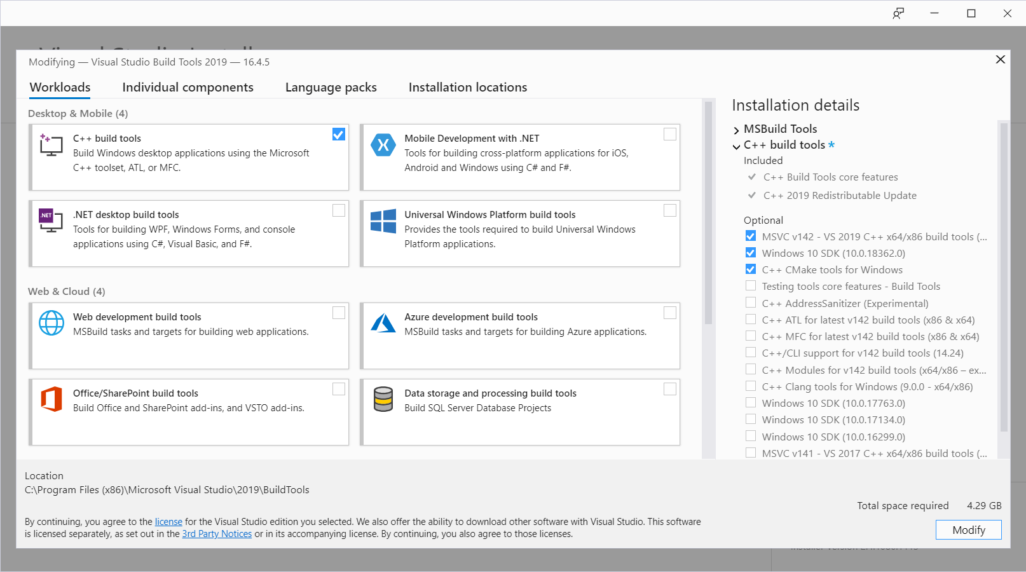

**Part 1: Blender Interface**

**Summary of video tutorials 1 to 3 for Blender 2.80.**

Video 1: <https://www.youtube.com/watch?v=MF1qEhBSfq4&list=PLa1F2ddGya_-UvuAqHAksYnB0qL9yWDO6&index=2&t=0s>

Video 2: <https://www.youtube.com/watch?v=ILqOWe3zAbk&list=PLa1F2ddGya_-UvuAqHAksYnB0qL9yWDO6&index=2>

Video 3: <https://www.youtube.com/watch?v=8XyIYRW_2xk&list=PLa1F2ddGya_-UvuAqHAksYnB0qL9yWDO6&index=3>

**1. Summary of video 1: First Steps - Blender 2.80 Fundamentals**

Bender is open source software used for 3D animation and modelling. Used in TVseries and Games. It can also do video editing, compositing, painting, sculpting, visual effects, simulation (fluid, smoke, particle and cloth), 3D printing, 2D animation and real time rendering.

  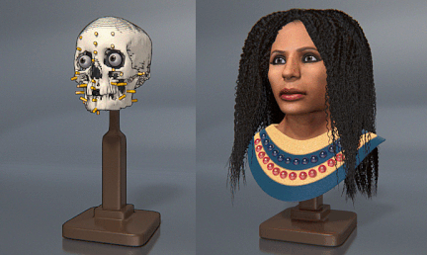

The Secret of Kells (2009) SpiderMan-2 Forensic reconstruction

**2. Summary of video 2: Viewport Navigation - Blender 2.80 Fundamentals**

Have Blender 2.80 open on your computer, watch the videos and then use the notes below to allow you work your way through the user interface controls.

2.1 Selection

Select is left-click on object, deselect is left-click on empty space; an orange line appears around the selected object.

Press **a** to select All objects, **Alt a** to deselect all

2.2 Navigation

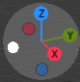Use the gizmo top right to rotate

Rotate

Left click on the X, Y or Z moves view to an orthographic view (plan) along the axis clicked.

Left click on the grey circle region (button down) drag to produce an off-axis view

Use the magnifying glass to zoom, hand to pan, camera to see render view, and grid to set perspective mode.

Pan 

The pivot point for rotation is the origin, left click (and hold down) the hand icon to move (by dragging) the new origin to the centre of screen. This allows you to pan along current the viewing plane.

Zoom 

You can zoom in and out using the magnifying glass icon. Click and hold the button down and then move the mouse to change the zoom level. You can also use the wheel on the mouse if it is available.

Move to centre of object

Right click on the cube then View –> Frame_selected will centre the view on the object selected (the cube).

View from the camera (rendered view) 

The camera Icon allows you to see the scene from the point of view of the camera.

Aside: Pressing F12 will allow you to produce a rendering of the cube from the point of view of the camera. The camera might need to be configured to use ‘cycles-ray tracing’ rather than ‘Eevee-fast physically based’ and set resolution to 50% to reduce the render time, <esc> to interrupt the render.

The grid icon,, allows you to change from perspective view (realistic - small far away) to orthographic (objects don’t scale with distance).

**3. Summary of video: Coming to terms with the user interface**

The bar at the very bottom of the screen is a reminder of the mouse functionality available when hovering over a window.

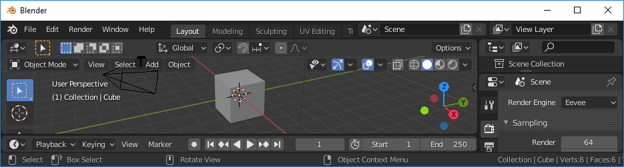

Left click and drag over objects to select them object

Left click to select individual object

Pressing SHIFT or ALT when hovering over window changes the functionality of the mouse and this is reflected in the bottom line

SHIFT 

ALT

Each panel can be resized and changed to any format. You can design the blender layout to suit your workflow. The panel can be changed be left clicking in the top right of the panel and selecting an alternative editor (typically data editors are found on the right hand side of the screen).

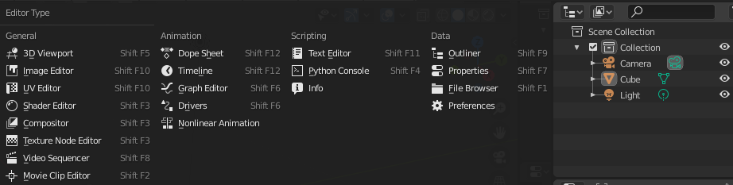

To create additional panels, you can right-click on the boundary and select split to create two identical panels. One panel can then be changed. You can remove the panel by joining them, left click on the join and then click again on the panel to be removed.

Left click on the panel edge and drag allows you to adjust its size.

You can also create a new panel by dragging the bottom right corner of a panel upwards or left so as to split the panel.

Ctrl <space> allows you to maximise a panel, pressing crtl <space> a second time returns to the normal panel view.

Very quickly you can reconfigure the blender window to create a workspace to suit your workflow.

Default workspaces are listed across the top of the window. You can click on the tabs to select them. The “layout” tab is the default panel configuration.

**Moving and orientating objects already in the scene**

Getting to know the editor, T & N

You can expand the tool bar by clicking on the small tab on the left,  or on right for viewport options . Alternatively, you can press T or N to make the toolbars appear, or repeat the keypress to make them disappear.

The red and white shows the position of the 3D cursor. This cursor is used to position new objects (and to pivot around). The cursor can be positioned using the menu or by

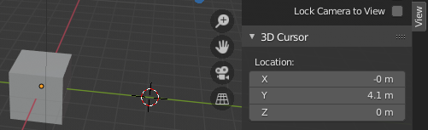

Left click down and then drag left/right to set cursor position on y axis.

Shift A - allows you to add an object at the cursor position. Try Mesh -> Cube. Remove the second cube it by clicking on it to select it and then right_click and select delete to remove it.

Shift S - produces a pie menu, use the radial cursor to select where cursor position should be position (try world origin, or preselect an object and cursor to selected). Right click closes the pie menu.

Z – pie menu describing how edit screen is rendered (wireframe, solid, rendered)

Blender supports multiple scenes. The scene properties can be changed using the following panel

Edit properties of scene/object

Object selection, drag over region of interest, add to selection, remove from selection

Rendering engine – Cycles (ray tracing slow), Eevee (modern real time), Workbench

Output – image or video, default folder c:\tmp, use Render tab to create output

View layer properties – blender 2.8 uses collections – layers are for backward compatibility

Scene properties – choose active camera, gravity, sound

World – sky and air properties - lighting



You can create additional scenes and select a specific scene using the scene tool bar.

Select existing scene

Create new scene

Delete a scene

Active scene



The properties of selected object can be changed using the following toolbar.



Object tab – select object then drag on grey menu bars to adjust

Modify object using predefined algorithms – e.g. round edges

Add particle systems to the object

Physics simulations

Constraints – relationship between objects

Mesh data – shape of the object

Materials – used for shading during render

Textures used in general not specific to object

The panel that allows you setup the layer being rendered is shown below, each layer is a collection of objects, cameras and lights. When you run scripts later you will see all the objects you have added listed here. Layers have been superseded by collections in Blender 2.80.

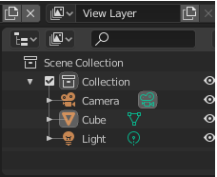

**Part 2: Creating video sequences and simple animation.**

**Summary of video tutorial 39-Timeline for Blender 2.80.**

We need to jump ahead so we can get going with some programming, in advance of this we need to understand key frames. To do this go through tutorial 39 Timeline - Blender 2.80 Fundamentals. We will return to the modelling in later in this tutorial. A summary of this video is included below.

Left click on the cube to select it – it should be highlighted in orange.

Ctrl +2 will allow you to sub divide the sides.

Select ball and right-click and choose smooth.

We could have also deleted the cube and added a sphere instead Add – Mesh – Ico Sphere.

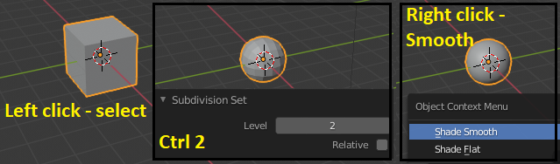

Press the white circle – record button (in centre above time line).

Press N to bring up the object properties

Adjust Z position until it about 4.

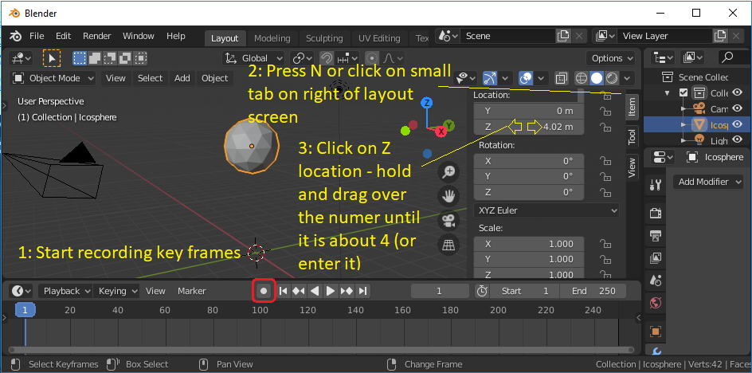

I could not get the auto-key frame working on my laptop so pressed – I “Insert keyframe” - Location to do it manually. I think the fist key-frame has to be added manually.

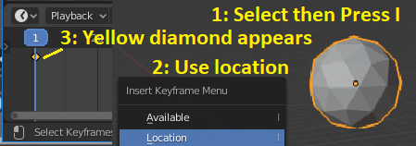

Move to about frame ten on the time line. The default frame rate is 24 frames per second, so 1 frame represents about 1/24=0.0416 seconds.

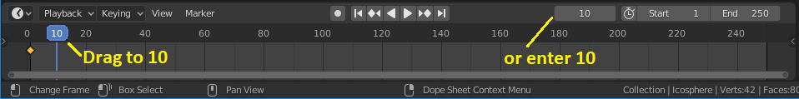

Use the transform menu (N) to return the spheres location to the ground, not through it (Z=1) and press – I again to set a second key frame.

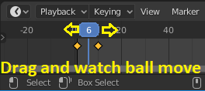

Drag the time line cursor back to around 1 and press the play button. The ball should drop.

You can now add another key frame at 15. Set the spheres position to about 2m. Good it will bounce.

Yellow diamond means active (selected) key frame, white (in active) not selected to be edited.

Note you have created key frames for just the sphere object (not the whole scene), if you select no object (just clicking in layout window) or select a different object then the key-frames will disappear from the time-line. Just reselect the object to see them or edit them. Each object has its own key frames.

Add a few more key frames to get familiar with the process.

You can zoom in and drag the time line into position by clicking holding and dragging the time line and the slider bar below it. Also using the wheel on mouse.

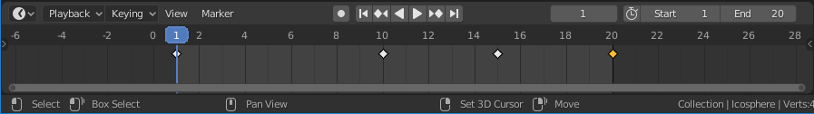

Finally, we can render an output video. The default setting is very slow so select the “Workbench” render in the render properties window (small tv icon). Set the output file format to AVI jpeg. For us this is a good choice as it only takes a few seconds to render the movie. On a big project you might render to individual frames so if there is a loss of power or crash you don’t need to go back to the beginning. Also set the resolution to 10% of (1920x1080).

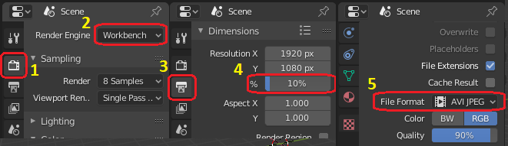

Click on render tab and select render movie. The file will be created in c:\tmp, you can change this folder in the scene output menu if you wish (the little printer).

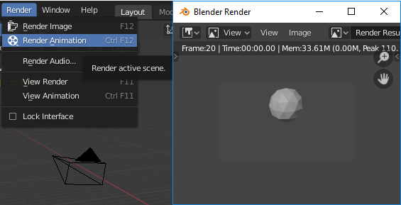

Open your movie file with a player (e.g. VideoLAN vlc)

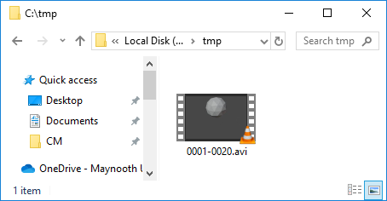 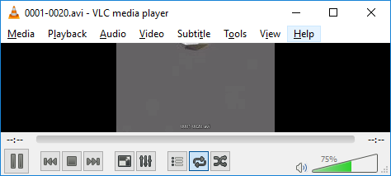

<https://www.videolan.org/index.html>

**Part 3: Summary of main edit tools, creation of an engineering object.**

Tutorial series: <https://www.blender.org/support/tutorials/> videos 4,5,6,8,9,10,11,12,13,14

Click on the blue section titles to see a suitable video.

**1. Introduction**

Designing models and scenes in the large 3D viewport window found on the Modelling tab is where most users of Blender will spend most of their time. Designing 3D model is an important aspect of Blender, you could argue it should have been where we started.

The aim of this tutorial is to show you how to create some simple objects using standard tools. This time we will create a cupboard door handle to introduce the main concepts.

Let us see what we can do…

**2.** [Select](https://www.youtube.com/watch?v=hTL6AKR8YDs&list=PLa1F2ddGya_-UvuAqHAksYnB0qL9yWDO6&index=5&t=0s) as simple as ABC

Launch blender and click on the Layout tab at the top of the window.

Select:

* Left Click on the object to select it.
* Left click any empty space on screen to deselect object.
* A to select all objects including camera and lights.
* <Alt> A to deselect all.
* Select box tool, left click drag over objects to select them.
* Deselect <ctrl> left click drag over objects to deselect them.
* B and middle click drag rectangle can also be used to select.
* C and middle click (circle mode, mouse wheel sets radius of the circle) pass circle over all objects you wish to select (like a brush), right click to leave B and C mode.
* <shift> and left clicking objects individually to select then (2nd click deselects them).

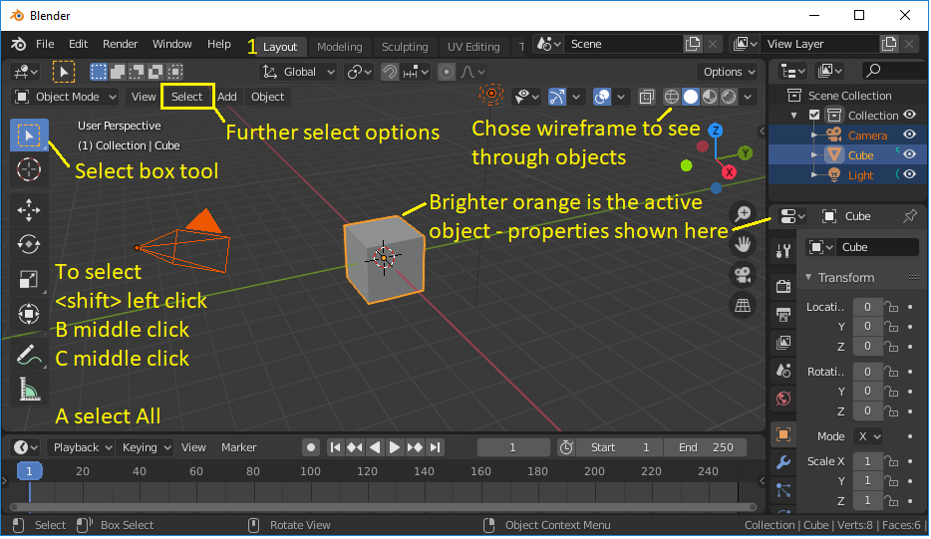

Sometimes it is better to work in wireframe mode so that you can see through objects obscuring the object of interest and select otherwise hidden vertices. Solid allows you to select foreground vertices.

Press Z and select wireframe mode or click on the wireframe button 

3. [Transform](https://www.youtube.com/watch?v=hTL6AKR8YDs&list=PLa1F2ddGya_-UvuAqHAksYnB0qL9yWDO6&index=5&t=0s)

Translation: You can select the move button to allow you to translate the object within the scene. Dragging the arrow head allows you move the object in one direction, dragging the square allows you to move the object in two dimensions. You can right click the mouse to abandon a move.

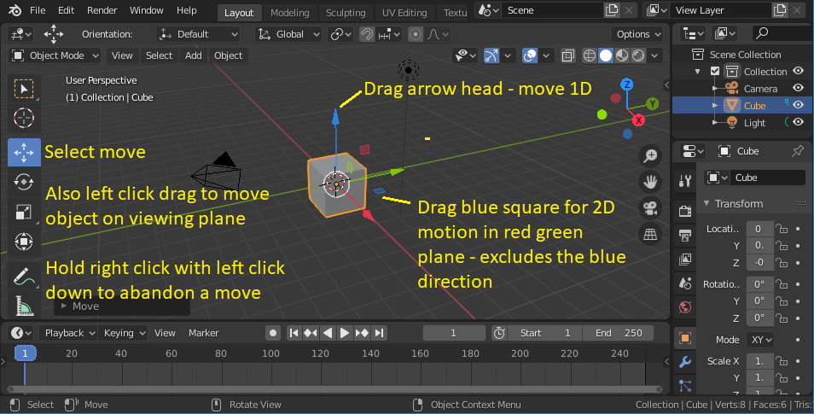

Hot keys GSR: Previous versions of Blender made more use of Hot Keys, you can use G grab then press X,Y,Z to select axis and then mouse drag to set position, <return> to accept, and <escape> to abandon. A double press of XX allows you to rotate about a local (one press X) or global axis (two presses of XX), <shift> X allows motion in YZ plane. Similarly, S scale and R rotate, try RX45 to rotate a selected object about X axis 45 degrees. Typing in dimensions and angles is important if you want to maintain accuracy.

<Alt> G returns object to its original position prior to the movement. This works in Blender 2.8 and can be very fast once you have learned it.

Rotation: You can select the rotation button and then use the gizmo produced to rotate the object.

You can use the red, green and blue rings to rotate about different axes. The inner track ball sphere can be used to rotate in all directions. The outer ring allows you to rotate about the view plane axis.

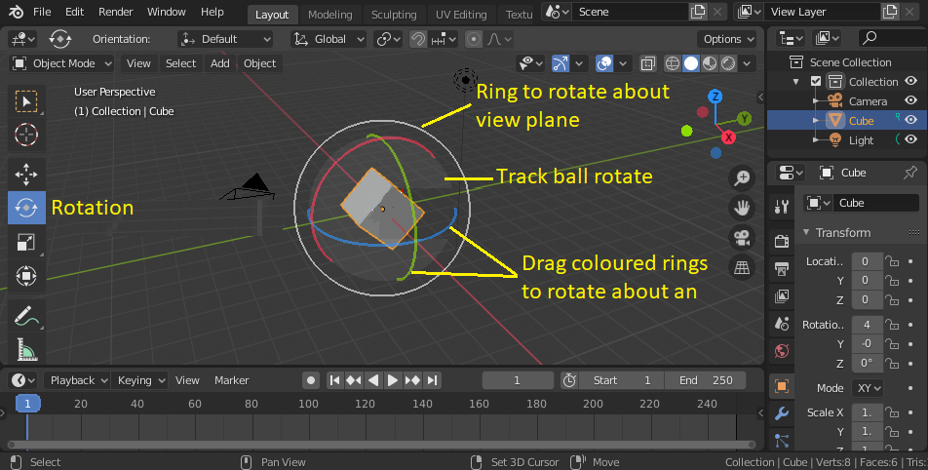

Scale: You can use the scale button to rescale a selected object in the direction of each of the axes. <Alt> S undoes any rescaling done in error.

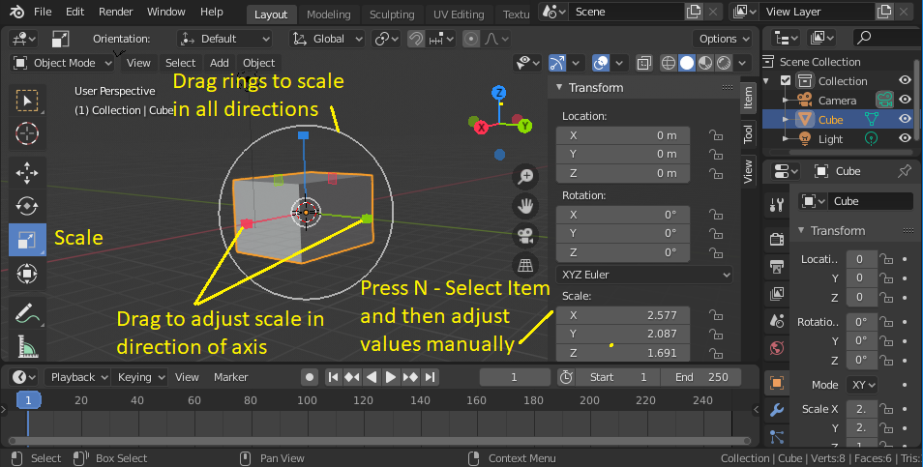

So far all transformations have been about the centre of the selected object. This is the orange point that represents the pivot point. You can change this to the cursor using the Transform Pivot Point drop down menu. The position of the cursor is best set by pressing N and then left click dragging left/right over the co-ordinate value on the menu (not the cursor itself) or type in the value.

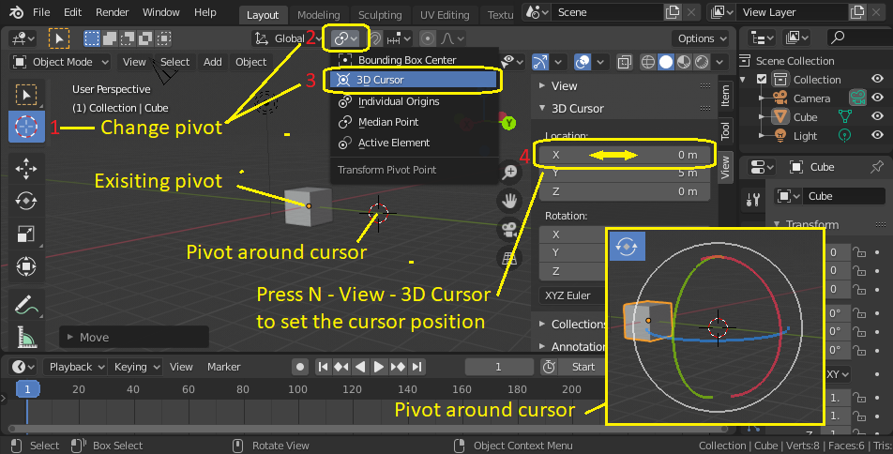

4. [Add](https://www.youtube.com/watch?v=JSAobQPRLwc&list=PLa1F2ddGya_-UvuAqHAksYnB0qL9yWDO6&index=6&t=0s)

Press <shift>A or go to the add menu. You could add the mesh describing a torus from the drop down menu. The new mesh spawns at the location of the 3D cursor, press N and select View-3D cursor and move the cursor to (0, 4, 0), then add a Torus. Click on the Torus to select it return to the properties menu (press if you have reduced it) and select Item and use this menu to set its orientation, dimensions and position. Most meshes are self-explanatory, the monkey mesh is a slightly more complicated low polygon mesh used by Blender for testing. The monkey is called Suzanne. The highest award in Blender animation is the “Suzanne Award” it is given annually to the best animators using Blender.

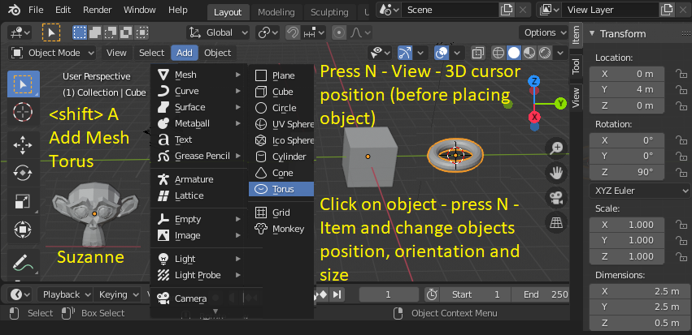

To delete an object just select it and then press X and confirm (left click) or use the delete key that does this without confirming.

`

5. Deleting parts of a mesh:

Remember you can press <ctrl> Space to enlarge a window and then repeat to return to normal.

Switch to the “Layout” and switch from “Object mode” to “Edit mode”, this will give you access to the vertices, edges and faces of the objects in your scene.

Use <shift> left click to select four vertices of the cube and then press <delete>, in response to the popup menu select “Faces”. This will give you a box with an open side.

Remember you can also use A to select All, B (+Left click down) to drag a boundary over or C (+ left click down) to brush over the vertices you wish to selects. Right click and then choose what to do e.g. <delete>. Use solid view to select front facing vertices or wireframe to select front and back.

Try selecting four vertices and using <delete> to delete vertices, edges and faces to see the difference.

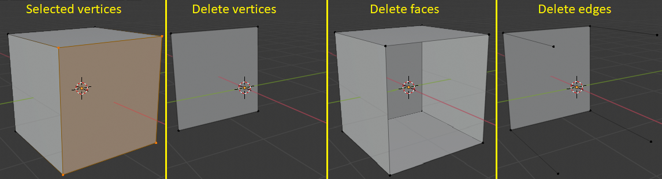

Ring cut:

There are also a number of more advanced delete options. To explore these options, we will need to do a “ring cut” of the cube (or object nearest the mouse pointer). Make sure no vertices are selected and press <ctrl> R, move the mouse around the outside of the cube to select the cut direction then left click (hold down) to move the cut to the position you would like (in this case roughly the middle). Left click again to complete the cut.

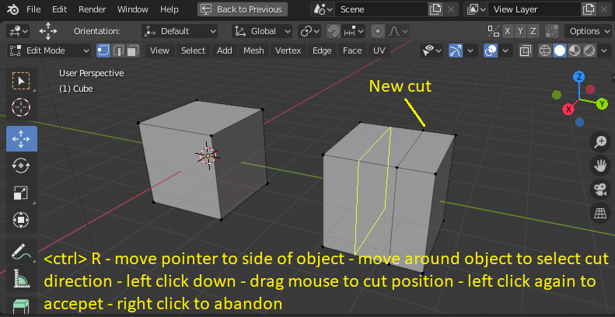

The following options from the <delete> drop down menu.

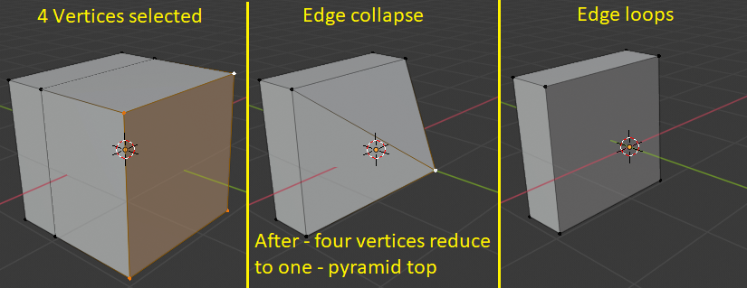

6. [Collections](https://www.youtube.com/watch?v=u_yIGGhubZs&list=PLa1F2ddGya_-UvuAqHAksYnB0qL9yWDO6&index=6) (Groups and Layers)

You can group items together in a collection. For example, you could create a background collection and characters collection. You can then work on the collection as a group. For example, you could turn off the background or change the way it is rendered separately to the character collection.

Add the monkey (Suzanne) to the scene and add a cube of width 10 to represent the background. Right click on the scene collection and add new, repeat this to create two collections. Rename the collections by double clicking on each of them and then typing in the new name (Characters and Background).

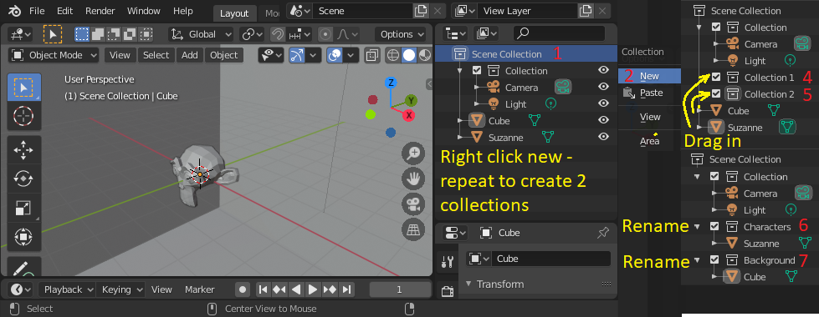

You can now turn visibility of the characters and background on and off independently.

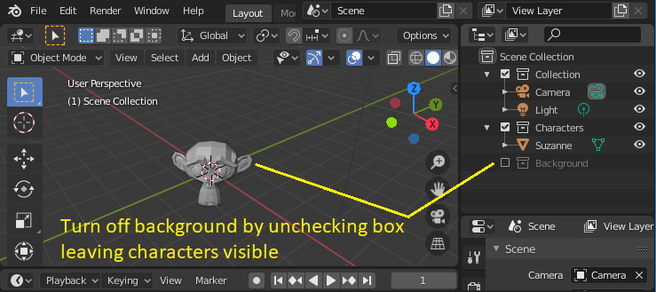

7. Layers: Each Scene collection can be set up to be worked on or viewed by selecting the visibility of items in the collection. A view layer allows you to have this set up in more than one way. You can add a new view layer and set one view layer to view and work on characters and another view layer to work on background objects and perhaps a third to see everything. The following shows this, the default names for the view layers were changed to “All”, “Background view” and “Foreground view” by double clicking on the default name and typing the new name.

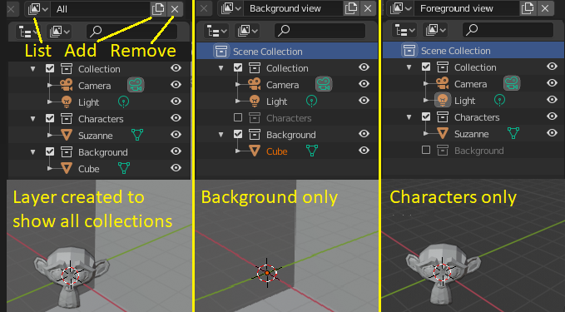

Note: deleting collections only moves objects, it doesn’t delete them. There is always at least one view layer.

8. Modelling and modification

At last we get to the interface that allows us to create our own models. Click on the modelling tab and look at the extensive list of options on the left hand side of the window or press <shift><space>. Many options we already know but there a few new ones that we need to know.

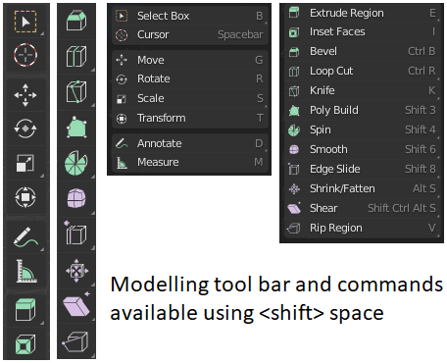

In general, make sure you are in “Edit mode” when using the “Quick tools menu” (on the left), you will also need to have an object selected to be in this mode.

In addition to the “Quick tools menu” on the left there is also a “Modifier” tool on the right.

In general modifiers found on the right of the window are best used when you are in “Object mode”.

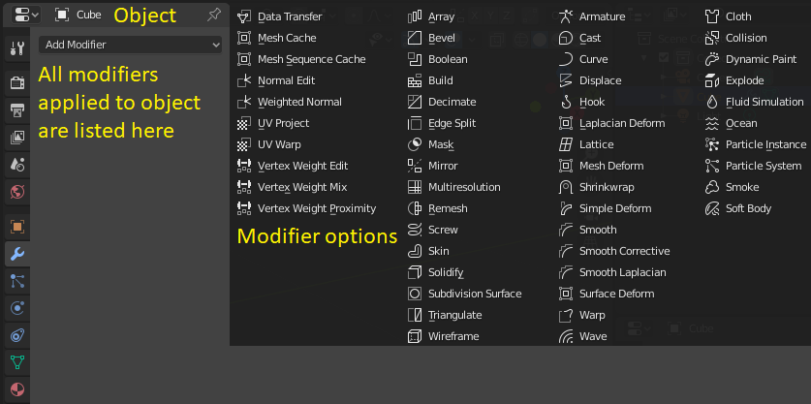

Don’t rush to “permanently apply” the modifier sometimes it is better to have it applied but adjustable as it can be something you want to keep control of.

The modifier acts on the object as if a property of the object. At some point in development you can decide to “apply” the modifier to make the modified object into a new object described by a single mesh.

If you add an object or mesh in “Object mode” it will become a separate object. If you add an object in “Edit mode”, then it will become part of the selected object on entering the mode. Below are shown two UV spheres added to a scene. One in edit mode with the cube selected (on left), the other in object mode (on right). Note how selecting the cube after doing this highlights the mesh of the single object consisting of the cube and sphere (on left).

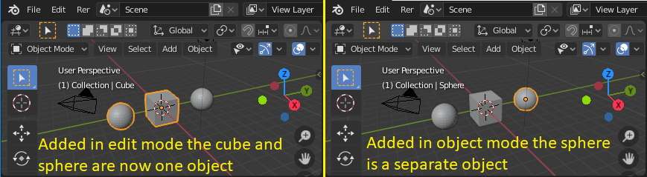

Note: 1: you can toggle between edit node and object mode using <tab>.

2: you can undo any action using <ctrl> Z and <ctrl><shift> Z to redo

3: you can select more than one object before going into edit mode

If you enter edit mode with a number of objects selected, then each vertex group is treated separately. You can’t create surfaces between the two objects. However, if you join the objects this becomes possible.

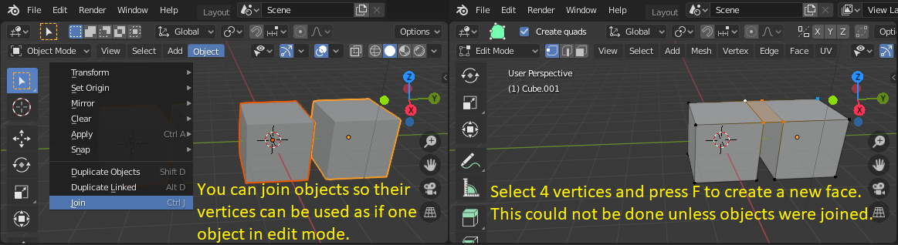

By selecting the relevant vertices (normally in wire frame mode) in edit mode you can separate the two objects (although they won’t have the same name as before).

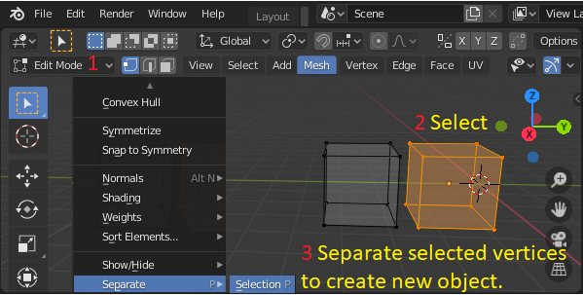

In edit mode you can select vertices, edges or faces. The default selection mode is vertex, but you can use buttons at the top of the 3D viewport to work in term of edges or faces. Selecting two vertices will cause blender to treat the selection as an edge and three/four vertices as a face.

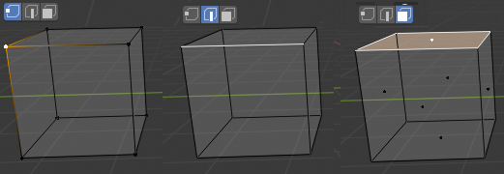

Modelling tools: Extrude

Create a cube, enter edit mode, switch to wireframe mode, select the top face and then select extrude. Left click down and drag the yellow + to extrude the cube – keep left click down and type 1.5 you should see the extrusion length change in the top left - release the mouse. You can also drag it but that is imprecise.

<ctrl> Z to undo the previous task if you got it wrong.

If you like short cut keys, you can do the same by pressing – select the face - E (for extrude) – type in the length – left click again to accept or right click to reject.

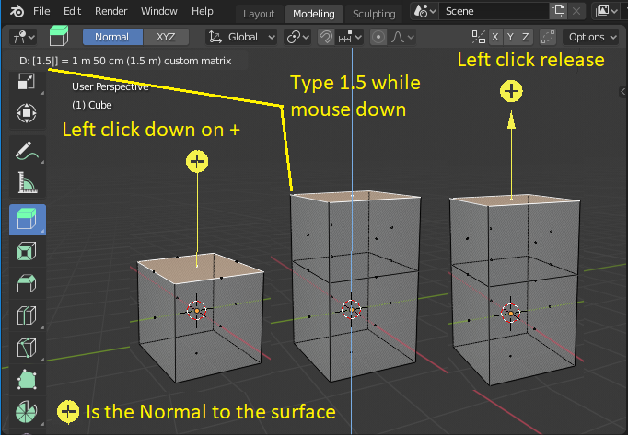

Instead of extruding along the normal direction you can also extrude in the XYZ directions in the object co-ordinate frame or the global co-ordinate frame.

Select a face and start extruding with E (or the extrude button and hold down left key) and then press X,Y or Z (to extrude along global axis) or repeat the press to extrude along object frame X,Y or Z.

Note: <shift> X,Y Z allows you extrude along two axes (not the one you selected).

Confidence test: Let us make the following shape

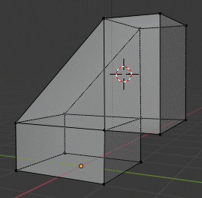

Start with a new empty scene and add a cube mesh or use the default one. Select the top face and use the transform button or G for grab (translate). In Layout or Modelling reduce the height of the cube by 1, i.e. type -1 during the grab.

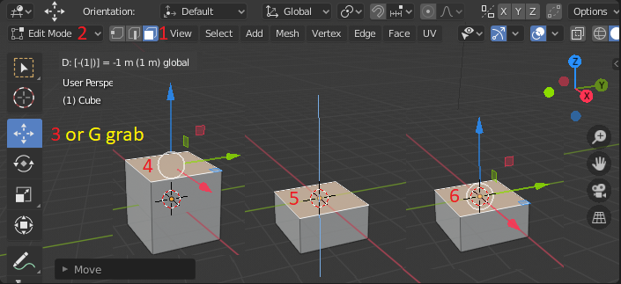

In Modelling extrude a layer from the top surface of height zero. This will add four vertices over the existing four forming the top of the cube.

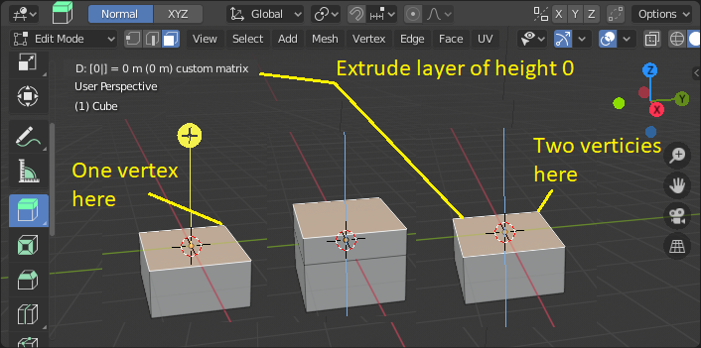

Press N and move the cursor to the top left hand edge of the cube. Change the transform pivot point to 3D cursor. Press N and set cursor position to (0, -1, 0).

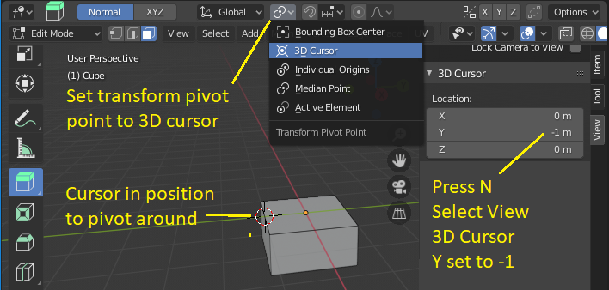

Select the top face of the cube and rotate it through exactly 90 degrees.

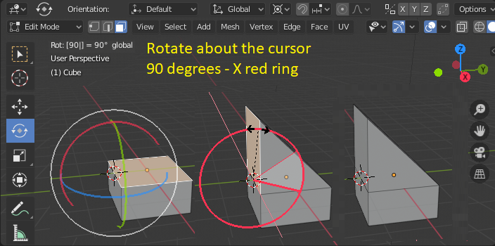

Now select the side face and extrude it a distance of 1m along the Y axis.

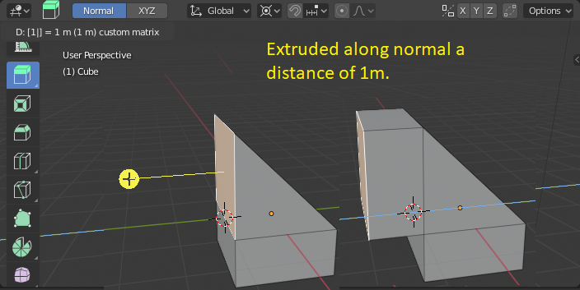

Nearly there: The object may look correct however some vertices are duplicated at the same location. This makes the new object difficult to work with, see below.

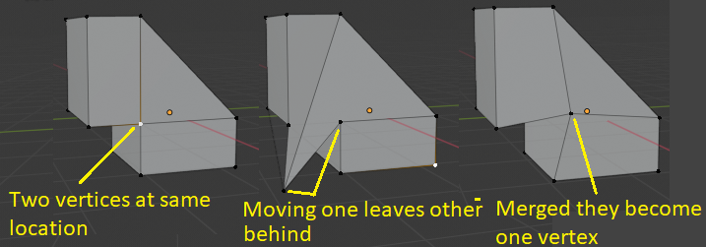

The duplicate vertices can be merged as follows. In wireframe mode select all vertices. Select Vertex – Merge Vertices – By distance – set the distance to 0.05m, the default value is too small to cause a merge to occur. You can also do Mesh – Clean up – Merge by distance.

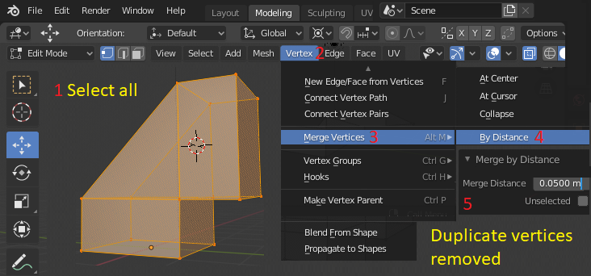

Now that we have the object, we can use a modifier to create a mirror image of it.

This will take a few tries – so have your <ctrl Z> ready to undo unsuccessful attempts.

Press the “3” on the number pad or X on the view gizmo to get a side view looking along the X-axis. We are going to mirror in the XZ plane. So first we need to move the object so that all of it is to the right of the blue line. Press A to select all (Edit mode) and use the translate tool or (press G) to move it to the left of the blue line. The object centre is the point about which the mirroring occurs. It happens to coincide with the global origin in this example.

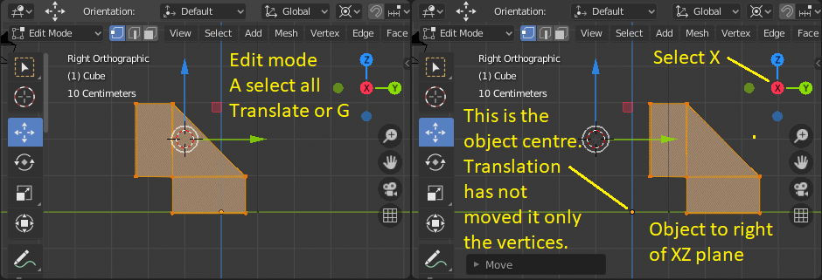

Although not critical the Transform point should be set to “Median point” it may be still on “3D Cursor” from earlier. Then click on the add modifier (via spanner icon) and choose the Mirror option. Uncheck X and check Y, check clipping (this will join vertices when they meet). Move the pieces together by left click down on the green arrow until they meet in the middle (within the clipping distance 0f 0.05m) and release the mouse. The coincident parts within 0.05m will join.

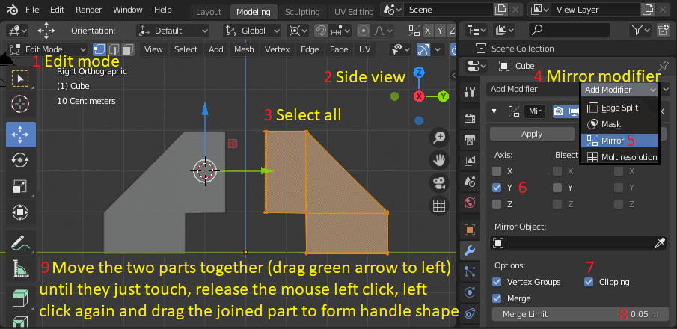

Drag the parts apart to form a handle shape. To be precise you can type in the translation as 1m.

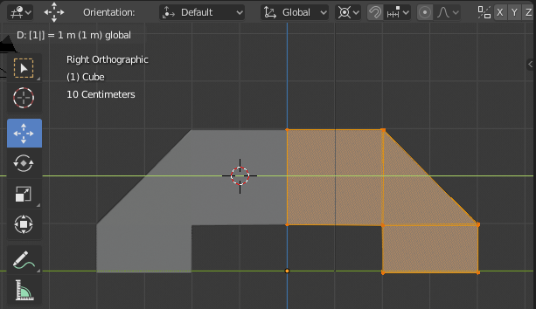

Return to a 3D view using the gizmo and set to wireframe you can see a plane remains between the objects. We should have removed it earlier but we can do it now.

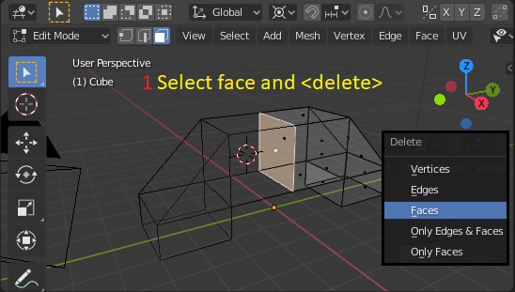

Finally, we can bevel the edges of the handle. In edit mode select all –A and then click on the bevel tool, press enter (or left click down on object and drag away from it) and enter the bevel size to 0.2m.

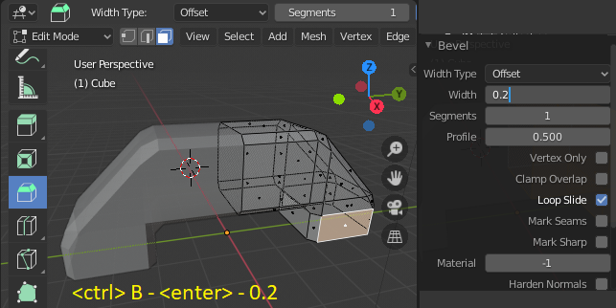

We can then View – Align View – Align camera to active view and render the handle.

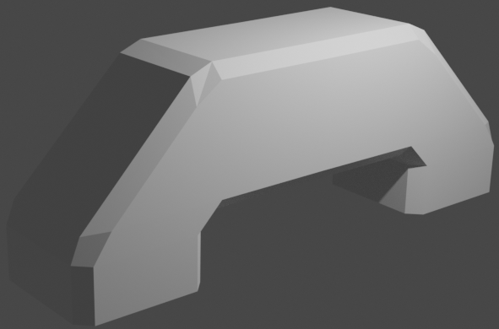

Good, we have created a simple handle shape and learned a lot about object manipulation on the way; throughout the process we kept dimensions precise. This an approach you could use for creating an engineering component. Alternative software for this purpose might be OpenSCAD (The Programmers Solid 3D CAD Modeller) and Autodesk fusion 360.

**Part 4: Creating a coffee cup.**

**Create a coffee cup** – this time we will go faster, see how much you can remember.

Move the handle you have made to one side. Add a sphere to the scene. Resize it to a radius of 10. In edit mode with wireframe turned on highlight the top region of the sphere using B and then press X to delete and choose faces in answer to the prompt.

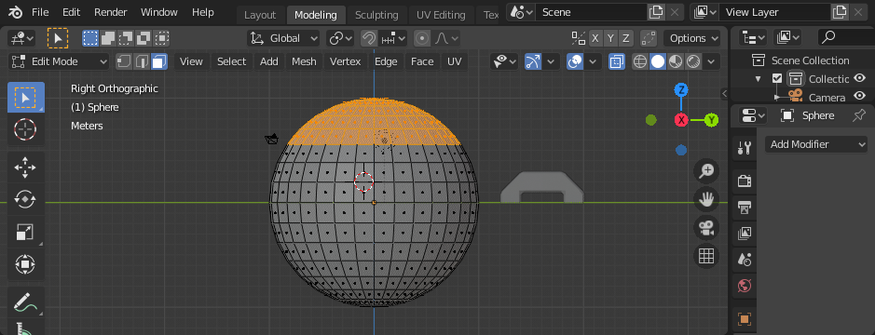

Highlight the bottom of the bowl created and rescale it so the Z axis values go to zero this will make it flat bottomed, B to select and the S followed by Z and type 0 in as the scale factor.

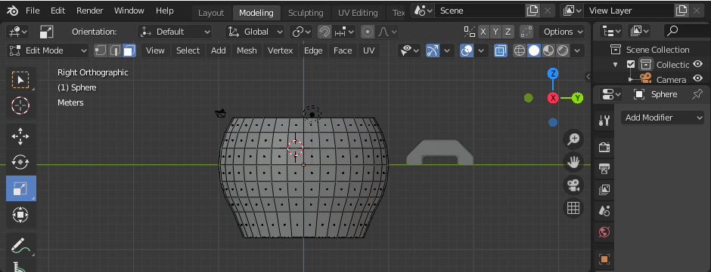

Use the gizmo to view the underside of the cup and highlight the inner region of polygons. Turn off wireframe so you only select polygons on the bottom of the cup, use C to select these polygons. Then translate or G and move in Z direction (blue arrow) so as to create a rim.

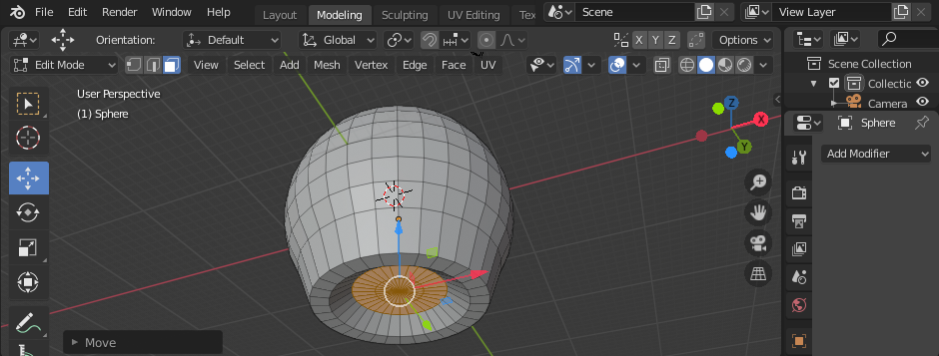

Next use the Solidify modifier on the body of the cup, do this in Object mode. Add a width of 0.1m to object and press Apply.

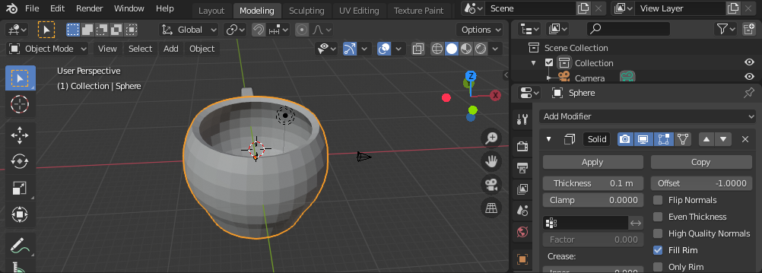

Take a side view of the cup, click on the X on the gizmo and select four faces that will become the handle. Rotate the view by pressing Y on the gizmo and use extrude E (and then X) to pull the start of handle out of the side of the cup.

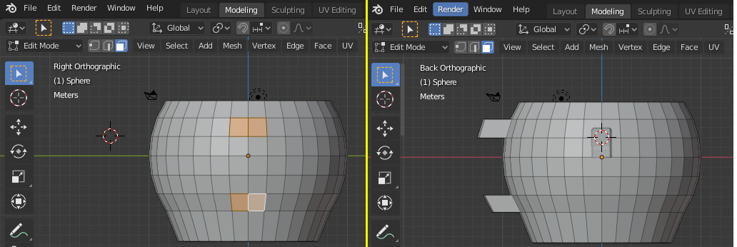

Select the two faces forming the top extrusion for the handle, press X on gizmo to rotate the cup towards you then rotate it to side view by pressing Y. The press R to rotate (it is good enough to rotate about median point). Once rotated, press E to extrude. Repeat the process until you arrive just short of the bottom handle connection.

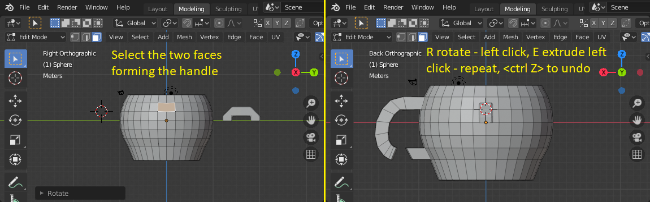

Delete the faces on the ends to be joined. Click on the first face and then <shift> click on the second, <delete>. Repeat on the other end.

Switch to edge mode and select the two edges (left click the first, <shift> left click the second) to be joined, you could select four vertices if you prefer (it is slower). Press F to fill and form a face. Repeat for the remaining edge pairs.

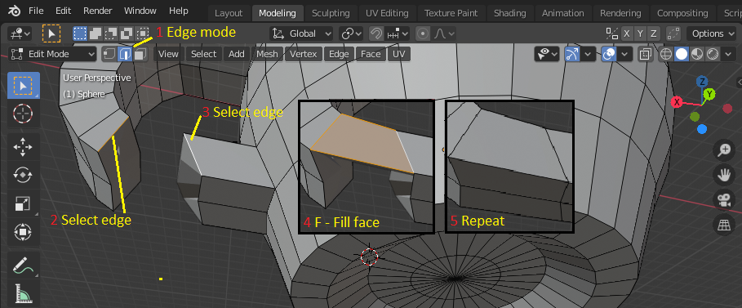

You can now smooth the cup by adding in Object mode a Subdivision modifier to the cup (keep the existing Solidify modifier). Set the subdivision in render and viewport two 2 (or higher if you like).

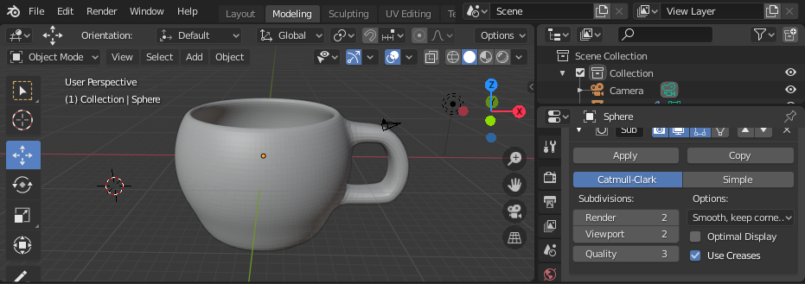

Finally, you can move the view into a good position and align the camera. View – Align View – Align camera. Then render your work, you may need to increase the clipping distance to 250 and increase the light intensity to 3000 or you could export the file and 3D print it.

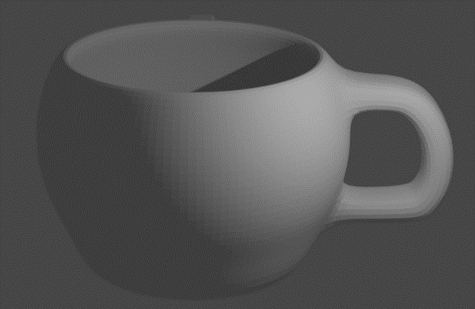 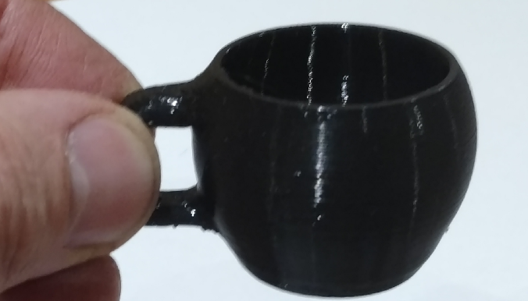

**Graphics Assignment 1:**

Create animated video that includes a coffee cup and another object of your choice (e.g. a sugar cube, spoon or biscuit). Submit the video and the blend file used to create it.

Remember the 9 short cut keys.

ABC-select,

GSR-Grab,Scale,Rotate

NTZ-Menus

**CM Feb2024**